**Realize and utilize potential: M + S Hydraulic relies on CADENAS’ eCATALOGsolutions technology**

The first customer from Bulgaria is already using the broad marketing potential of the electronic product catalogs

**Augsburg, Germany, 23rd March 2016.** M + S Hydraulik PLC in Bulgaria is a globally leading manufacturer of hydraulic orbital motors, hydrostatic steering units, hydraulic brakes and accessories. The company offers a wide range of motors and steering units in metric and SAE versions. The ISO 9001:2008-certified manufacturer turned to CADENAS to market their products on a broader and more international basis with the electronic product catalog.

**Find your way quickly to what you desire**

Since September 2015, all components of M + S Hydraulic are available via the 3D CAD model download portal PARTcommunity: <https://ms-hydraulic.partcommunity.com>

A clearly arranged catalog structure and extensive search features allow portal users to look for 3D CAD models, e.g. with the geometric similarity search GEOsearch or the performant full-test search. Users can look at the components, configure them and download them in a native format into the respective CAD system as well as integrate them into the existing design.

**3D PDFs are dynamically generated according to the product configuration**

The possibility for 3D PDFs was already available at CADENAS‘ eCATALOGSsolutions technology. To M + S Hydraulic it was imprortant that the complex data in 3D PDF could be generated according to the configuration. Therefore an extensive and sophisticated data sheet was designed:

The data sheet shows M + S customers, for instance, technical information about the product such as technical parameters , dimensions, characteristics of the load and all peculiarities that are assigned to the selected model. The graphics and diagrams are a highlight which are additionally displayed for some of the M + S Hydraulic product series. The data is collected dynamically according to the corresponding configuration of the user. Automatic calculations and adaptions are also stored in the data sheet.

Zlatka Alagenova, marketing expert at M + S Hydraulic: “CADENAS, is one of the leading manufacturers for 3D configurators, electronic product catalogs and online marketing and the only supplier who was able to create a PDF data sheet for us that meets our complex and specific requirements.“

**Pioneer from Bulgaria**

Jürgen Heimbach, CEO of CADENAS, is very pleased about this development: “M + S Hydraulic realized its potential and utilized it. The electronic product catalog combined with using the 3D CAD download portal PARTcommunity, are excellent prerequisites for the company to successfully market their products. Moreover we are very pleased to welcome M + S Hydraulic as our first customer from Bulgaria. Also in the future we would like to get more prospective customers in Eastern Europe enthusiastic about our eCATALOGsolutions technology.“

**Press Images:**

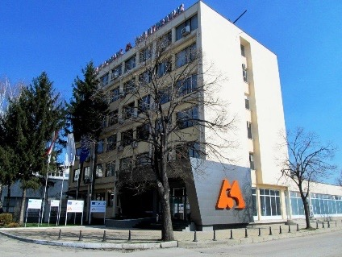

**Caption 1:** M+S Hydraulic PLC in Bulgaria is a globally leading manufacturer of hydraulic orbital motors etc.

C:\Users\alitzel\AppData\Local\Microsoft\Windows\INetCache\Content.Word\mshydraulic.png

**Caption 2:** Logo M+S Hydraulic PLC in Bulgaria.

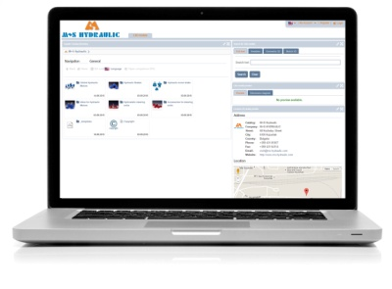

**Caption 3:** Since September 2015 all components of M + S Hydraulic are available at the 3D CAD models downloadportal PARTcommunity: https://ms-hydraulic.partcommunity.com

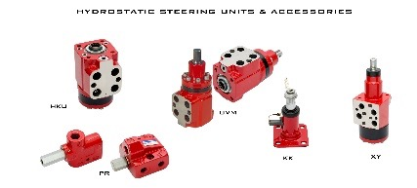

**Caption 4:** Range of Hydrostatic Steering Units and Accessories of M+S Hydraulic.

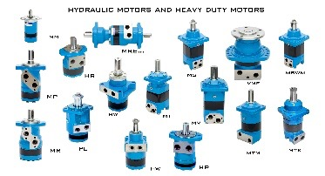

**Caption 5:** Range of Hydraulic Motors and Heavy Duty Motors of M+S Hydraulic.

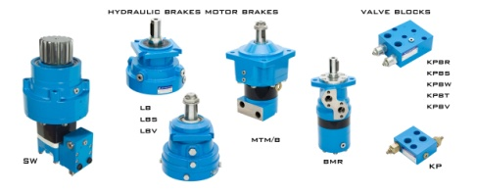

**Caption 6:** Range of Hydraulic Brakes, Motor Brakes and Valve Blocks of M+S Hydraulic.

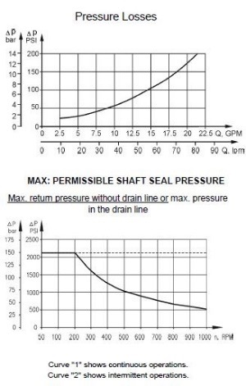

**Caption 7:** The data sheet shows M+S customers, for instance, technical information about the product.

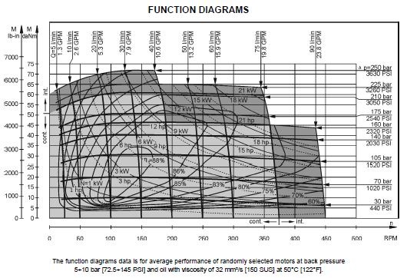

**Caption 8:** The data sheet shows M+S customers, for instance, technical information about the product such as technical parameters, dimensions, characteristics of the load and all peculiarities that are assigned to the selected model.

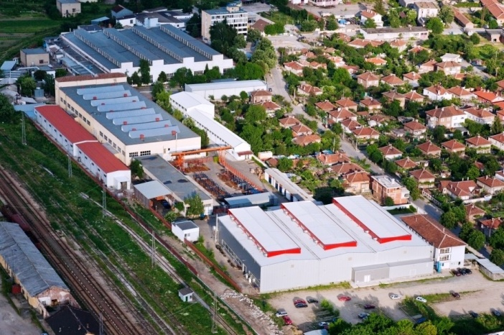

**Caption 9:** M+S Hydraulic in Bulgaria.

This press release and accompanying images are available for download from our website: [www.cadenas.de/press/press-releases](http://www.cadenas.de/press/press-releases)

**About CADENAS**

CADENAS is a leading software developer in the areas of Strategic Parts Management and parts reduction (PARTsolutions), as well as Electronic Product Catalogs (eCATALOGsolutions). With its customized software solutions, the company acts as a link between the component manufacturers with their products and the purchasers.

With its 300 employees at 17 international subsidiaries, the name CADENAS (Hispanic: process chains) has been standing for success, creativity, support and process optimization since 1992.

For further information, please visit: www.cadenas.de/en